RAW NOTES - Week 4

We are continuing with builder mode, and picking apart the app with the best possible intentions - and the information will be compiled into UX findings, recommendations and suggestions for further developments. They will be used only if they can be justified and if they provide value in any given UX or UI context.

Important: Missing Key + SPOTIFY FOR INSPO - elaborate..!?

No focus call has been arranged as of yet (to be updated in due course)
Still to look at this week:
1. Builder mode (in desktop mode)
2. Mobile testing (the smartest approach/planning considering this will be 80+% of users)
3. Analytics implementation (J spoke of something in week 3 focus call that needs to be recalled/included - already exists to a degree - more information needed)
4. Human testing - I think J needs to hear it from other people (what about Jade Ciao)

Any additional notes to go in here:

Decided on but to be confirmed - we bring in Jade Ciao - justification here is easy - any good consultant would bring in an expert for a session - and there should be at least a small amount of budget - to be cleared by Jeroen

Missing Key is a funky but cool idea - can this work? - this is when we start to draw in the same method outlined in the university report, which is description of thing/event/topic/idea/tech issue/whatever + feelings, evaluation, analysis and action plan - and think if we can start to develop a mini theme here throughout the builder mode and draw on theory to back out findings and also help guide Claude with the visual side of things + the creative suggestions - if we follow a framework and really dog deep on backing everything then the visual and verbal feedbacks will be far stronger.

Claude can draw on this to guide me through the UX testing in Builder mode - then we can review at end - STOP - decision made on Missing Key theory here to be woven throughout - way too bulky - Gibbs everywhere sounds terrible anyway! Let's find a solid UX framework to call all of this, ad then tie it in with Gibbs later on. What can be introduced specifically for the builder mode, which will no doubt do wonders for the report but also add real value for the builder mode because this is actually where the money is at in the app - getting this part right -
Builder Mode Evaluation Framework - tagged officially

—----------

Continuation of builder mode

We stopped at ambient music, where I wasn’t really sure what was going on in terms of the ‘ambient music’ box being the dropdown box and the part you are meant to click to access that part of the controls - it could be a bit more obvious and less DJ mixer/traktor software - in the sense that we will have all kinds of people on here and a lot of them will see this as ‘fiddly’ for want of better wording
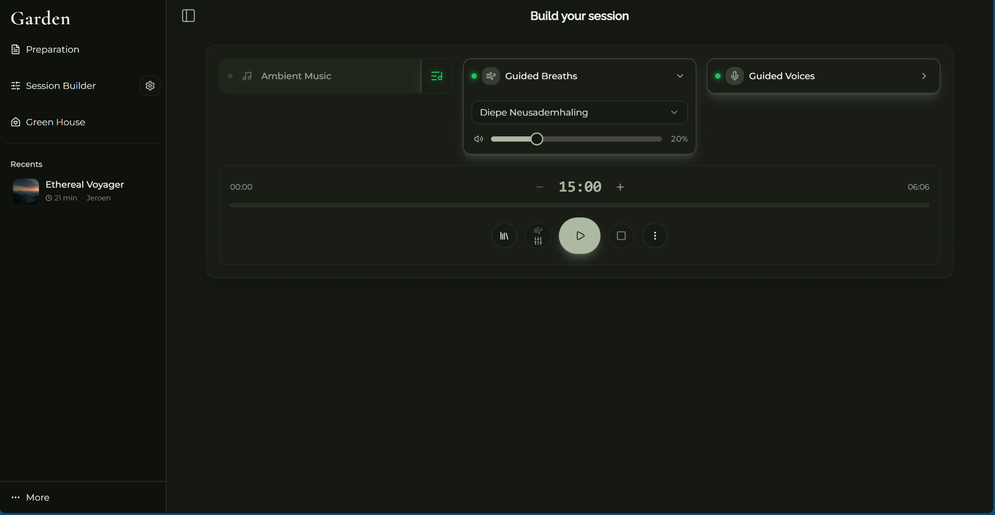
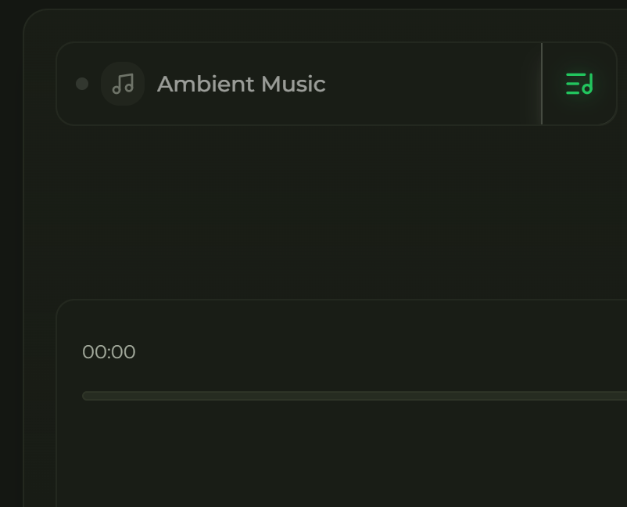

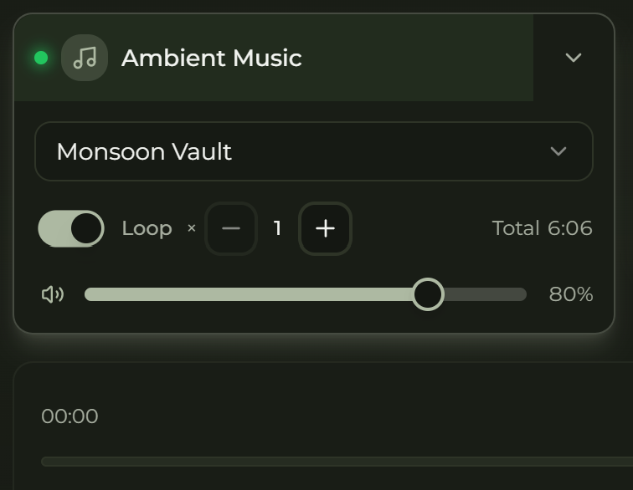

To me it looks pretty cool, but again I feel like I need someone to give me a guided tour and I shouldn’t really feel that way - implement missing key here to justify builder mode findings etc

So let’s do a trial test now and see how Claude responds to this document so far. Less is more because things are about to get deep!

—-------- back in the game on 24/06 —-------------

Moving FWD: Now that we have the ‘Missing Key’ and the using of Gibbs theory throughout cleared up, we will be moving forward with the below proposal instead, given that builder mode is by far the most important section in the whole manifesto.
Builder Mode Evaluation Framework - tagged officially

Okay so when I come back from Greenhouse or anywhere else, for example, and arrive at the controls, per say, this is what I see (this is what it returns to even if I collapse something and click out and return back in):
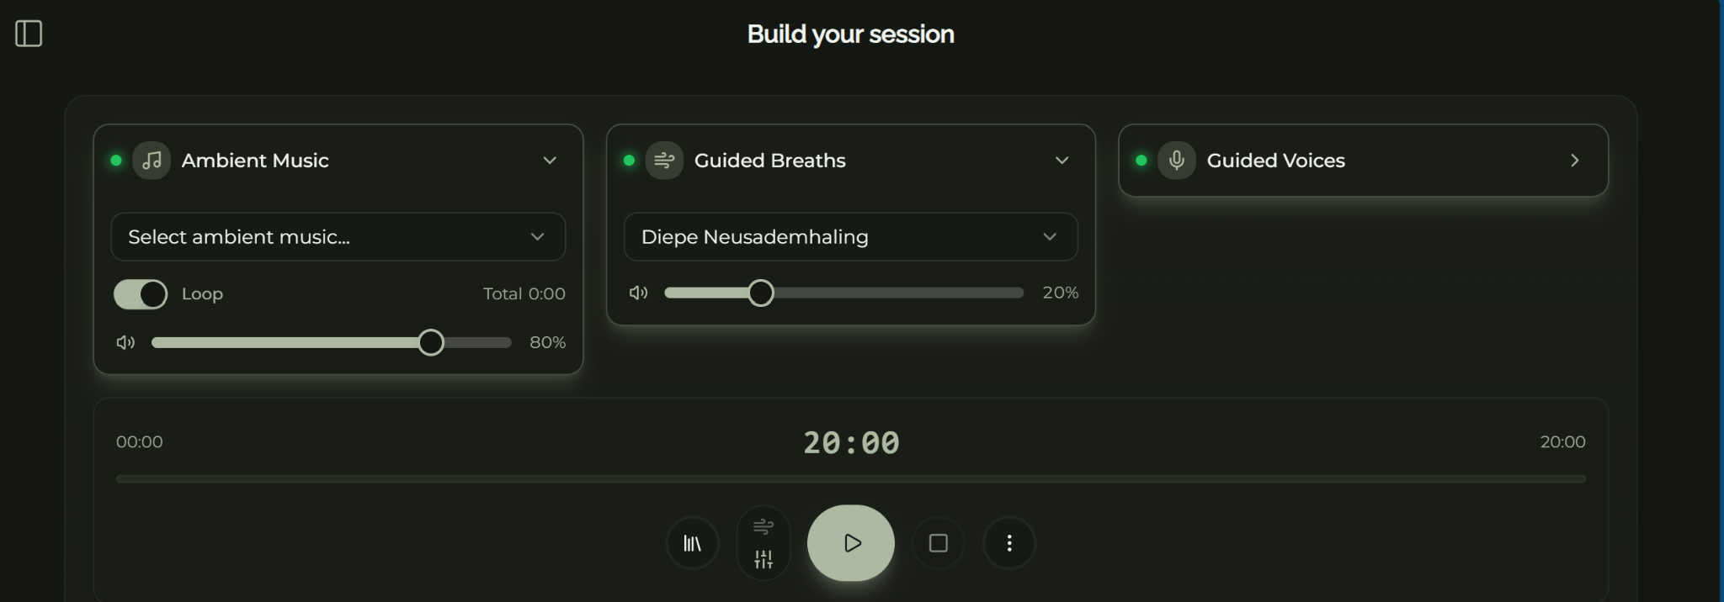

One thing I would note, and that is really cool, is that when I click on the right hand logo on the right side of the little music symbol
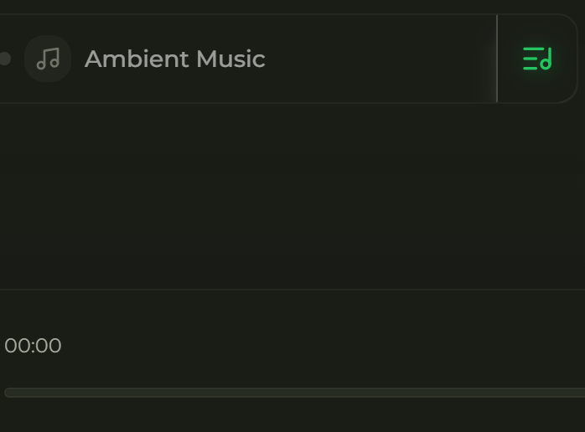

I get this, which is mega, but I didn't really expect that behind that button and there’s no real indication that this would give me spotify playlists or access to spotify, in fact I didn’t even know that could be a thing, so I’m a little confused
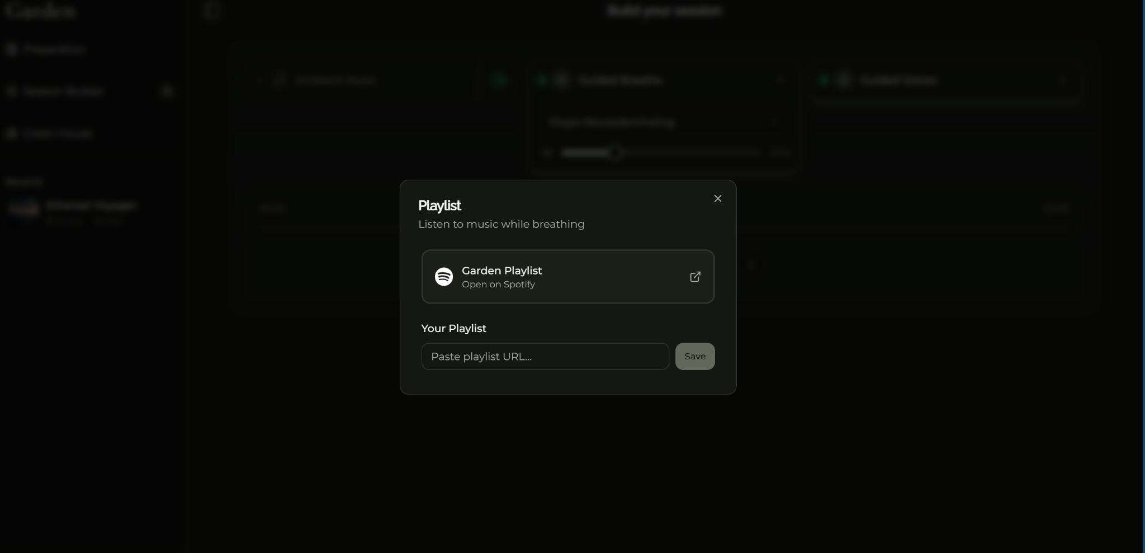

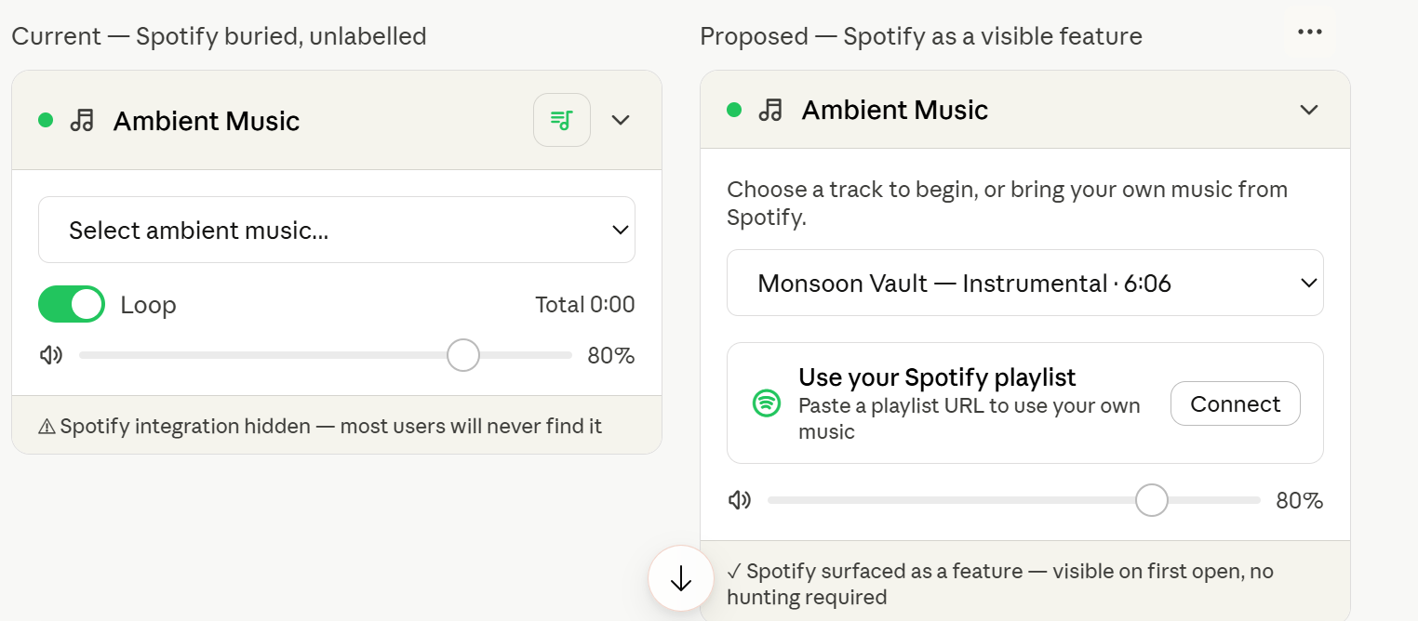
OR!!!

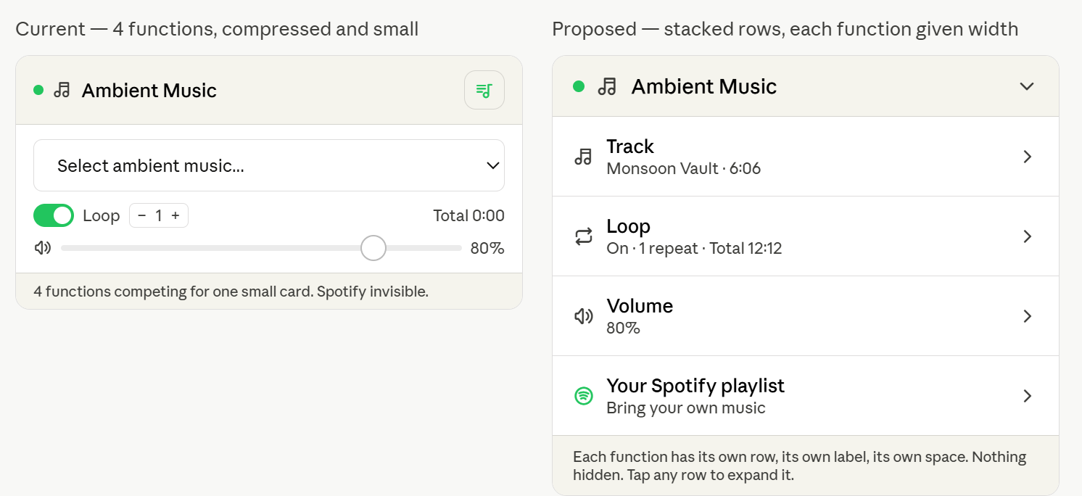
OR!!!

DOUBLING BACK!Going back to what the ambient sound bar/section actually is, there are 4 functions inc the spotify bit going on, and I don’t think people need to see all at once, and I think it shouldn’t be so damn small.
I think these would be better spaced one on top of each other with some width about them, and clearer toggles with little arrows or boxes to show the user what this actually does…
This is where I will start asking Claude to work with me on a sketch.
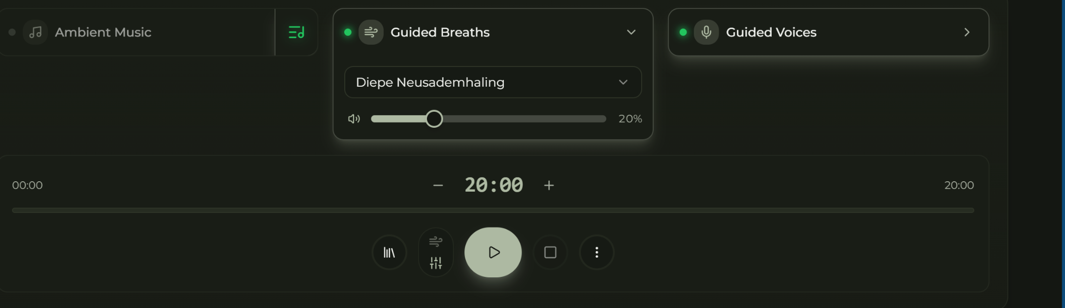

Could look like this (stacked!)...
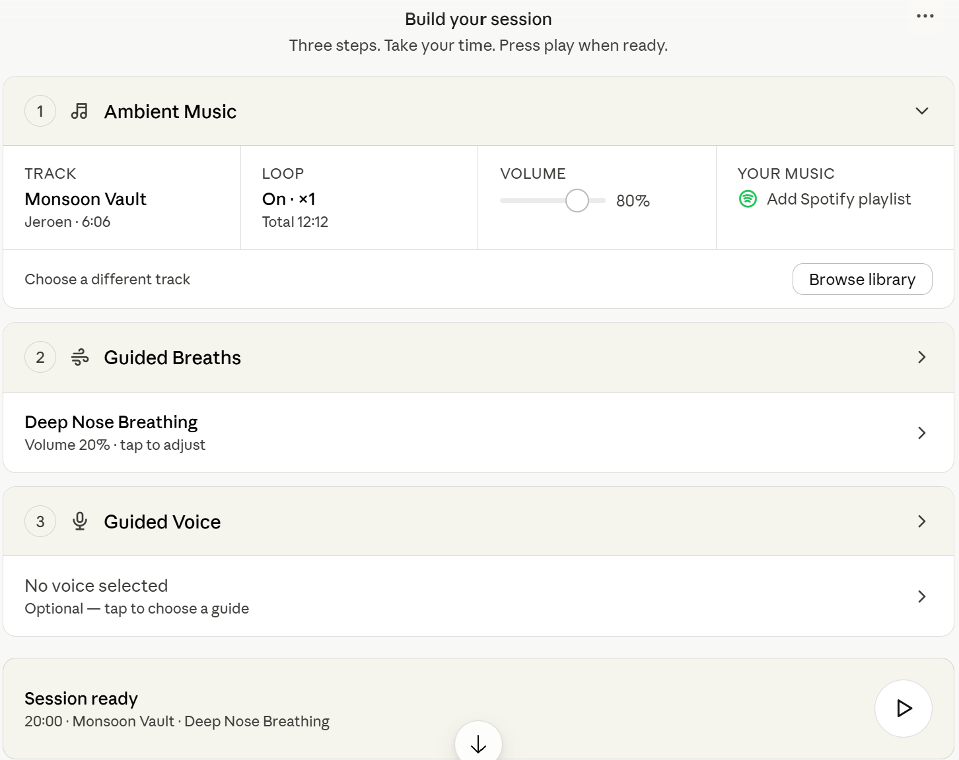

Focusing on what each box could look like/offer the user from left to right,
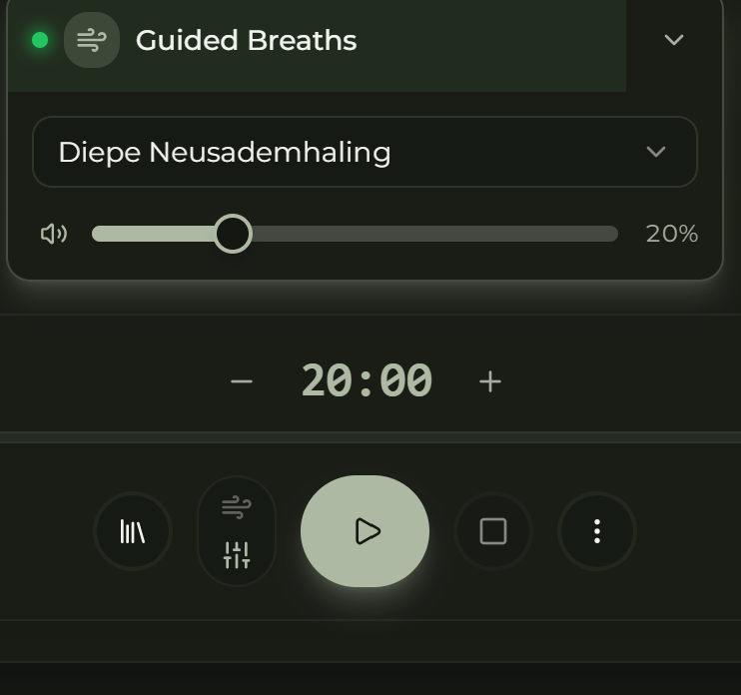

The above just looks really clicky - what is the glowing green dot and the symbol next to it? Looks pretty mystical and weird to me:

Clear enough but I wouldn’t usually click ona track name to get more, and also thelayout is overlappting the play button and controls
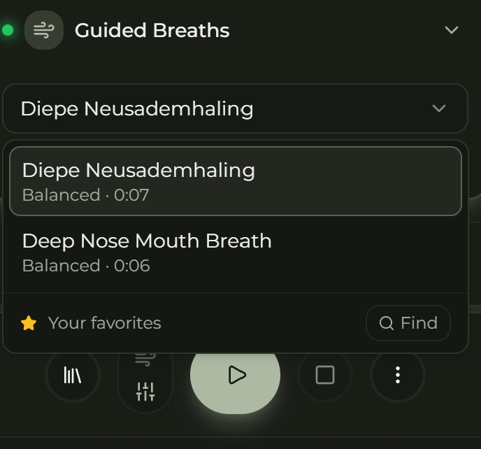

When I click on favourites, or the find logo with the spyglass, which is clear enough, this comes up which is a seriously strong point and should be used for the inspiration around spotify and the layout of Builder Mode - actually it reminds me of spotify and it is something we could be canny about here
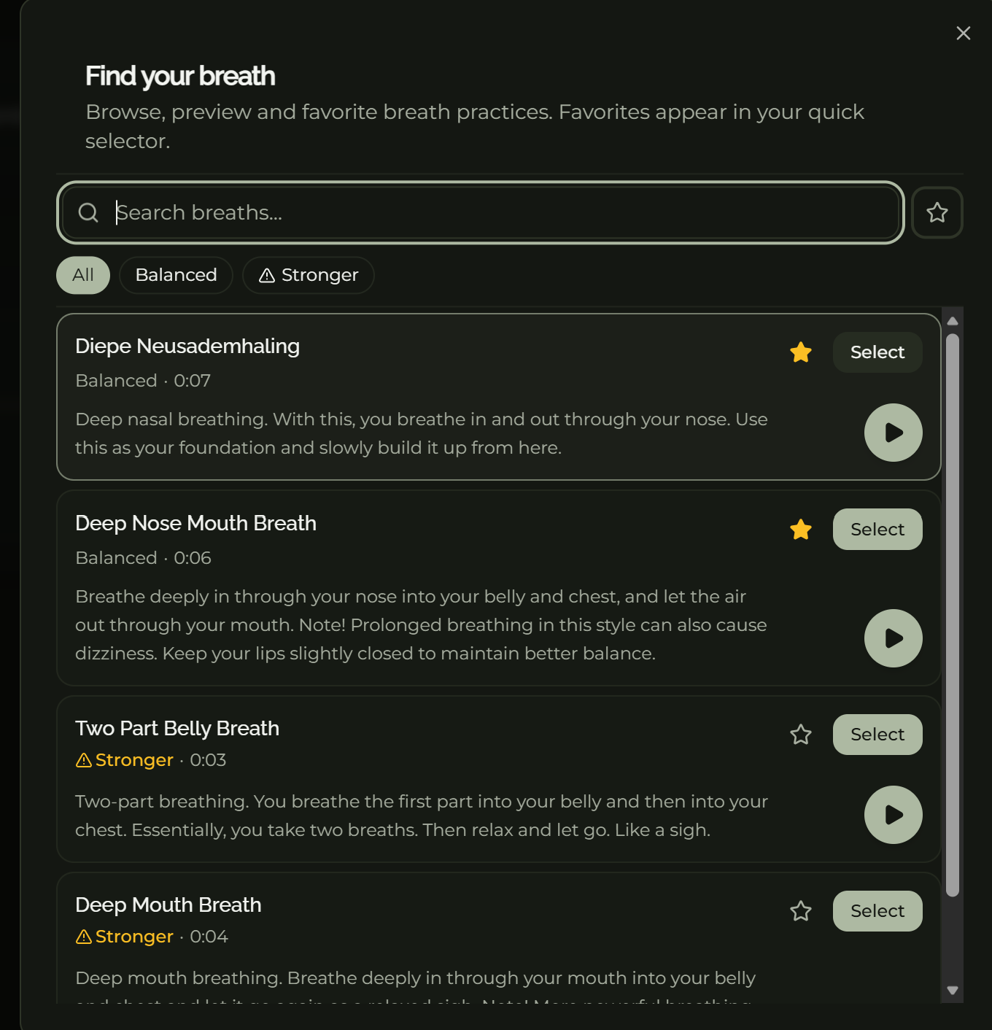

Also whilst I am looking at the middle card/section, I noticed these:
What on earth are these:
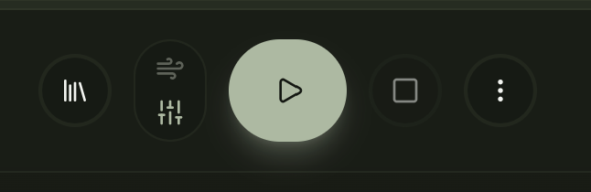
They make absolutely no sense to me and need addressed in builder mode - or now whilst we are here - this is a way to get people frustrated by giving them daft things to click on with not even a remotely clear idea what it might do - complex Traktor software levelled up
Breaking down what each of these actually do…
Clicking this:

Brings up this:
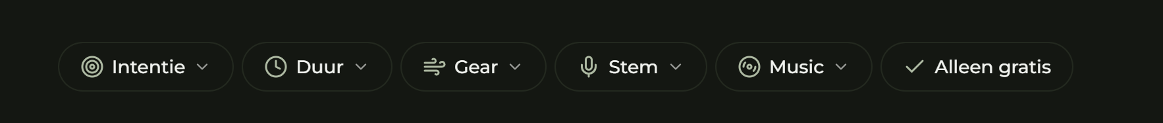

Clicking this:


Takes you to what I assume is preset mode:
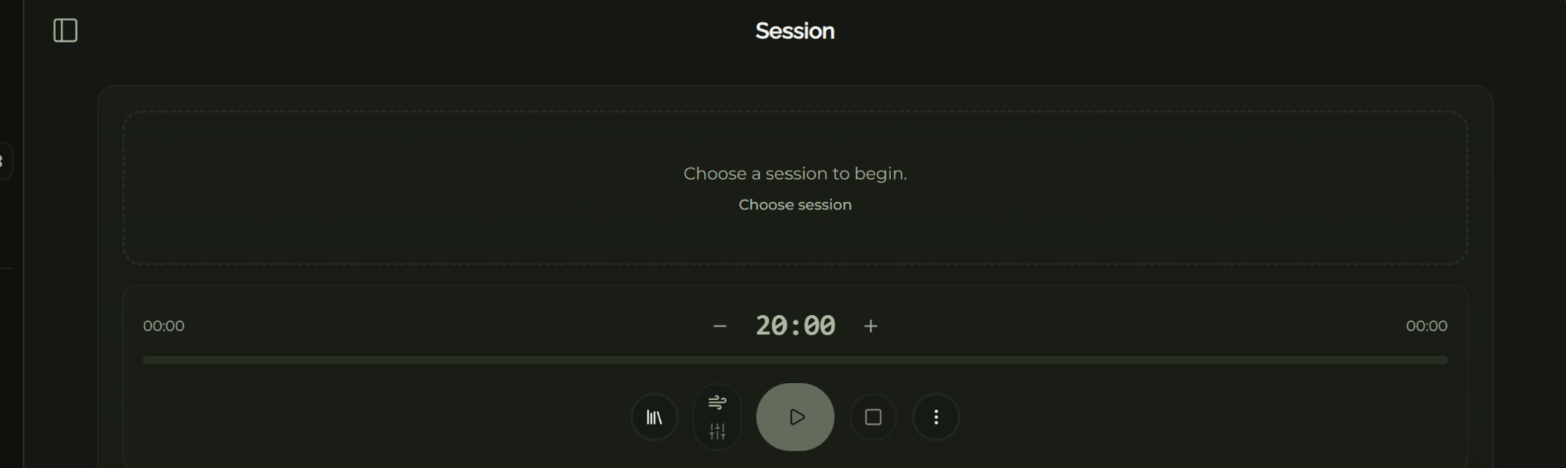

And clicking on the below:


Takes you back to what I assume is builder mode:
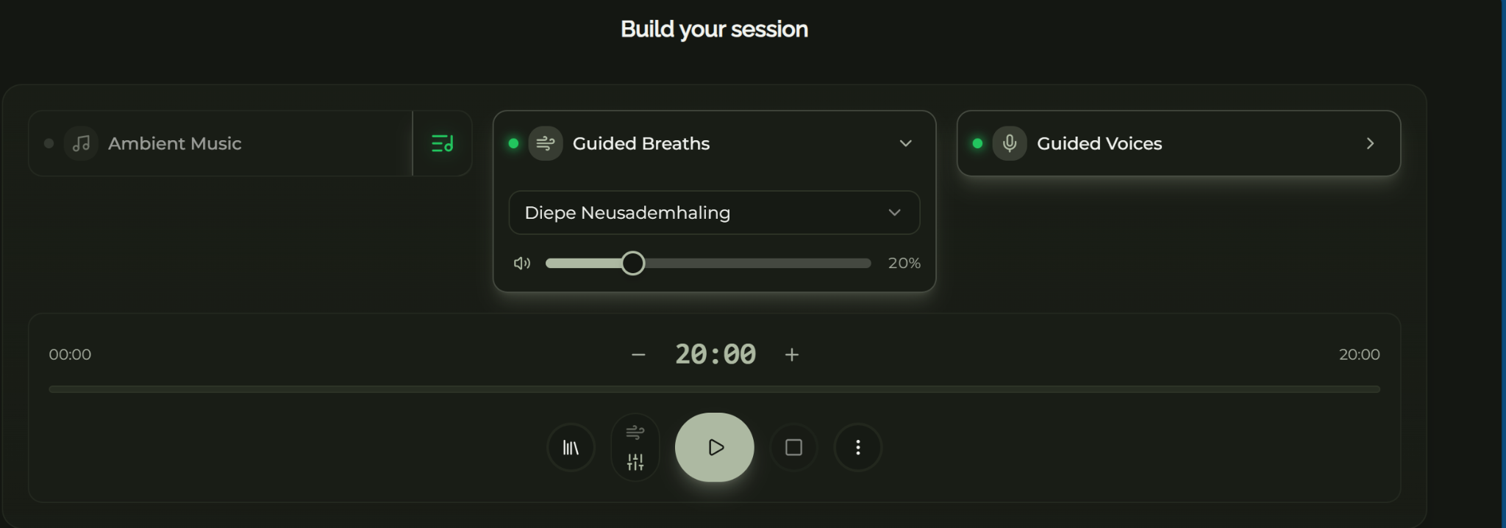

To start closing this feedback, I will finish on voices:

Is what I get when I click on guided voices bar
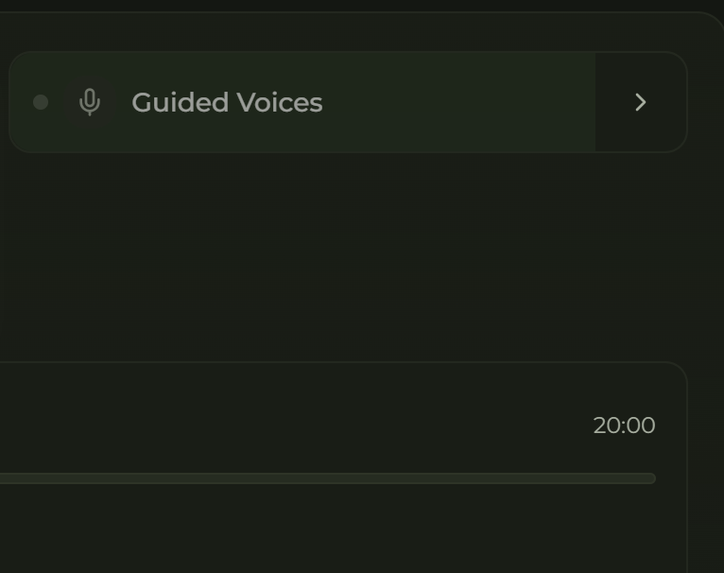

And then again when I click the same place:
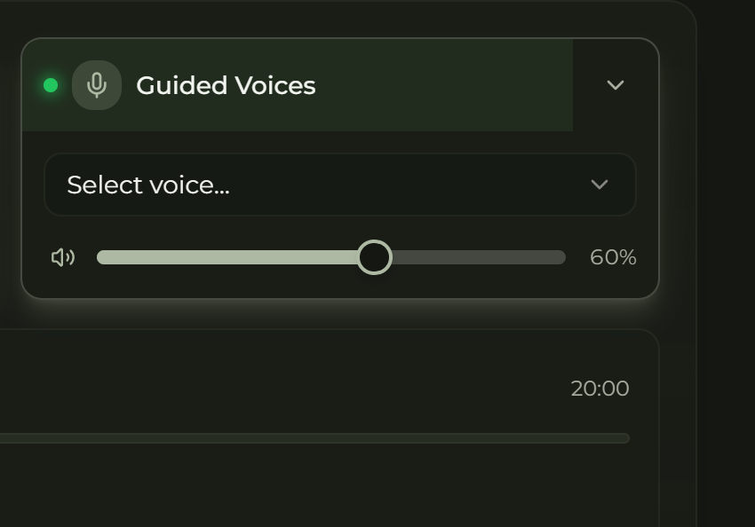
Not sure what the purpose of that click is or why it collapses?
When I click on select voice below noting happens, maybe because there are none yet recorded or logged?

Shouldn’t we beta in a selection process to continue finishing builder mode? Suggestions open
Volume toggle work on all three sections/cards

One thing I woud note is the three dots when I click on them I get:
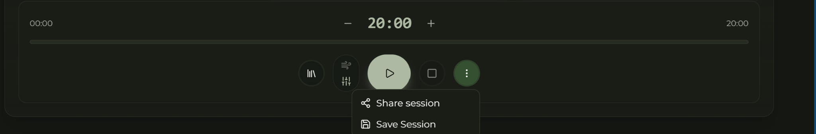
A great function could be better if there was a large box showing the art work and the selection made, from actually building a session, properly gift wrapped and ready for sharing with a friend. So using the concept of stacking them frome earlier, and the spotify-type look + the larger favourites box, try making an illustration of what a completed breathwork could look like that is ready to share or save!

So instead of the below:
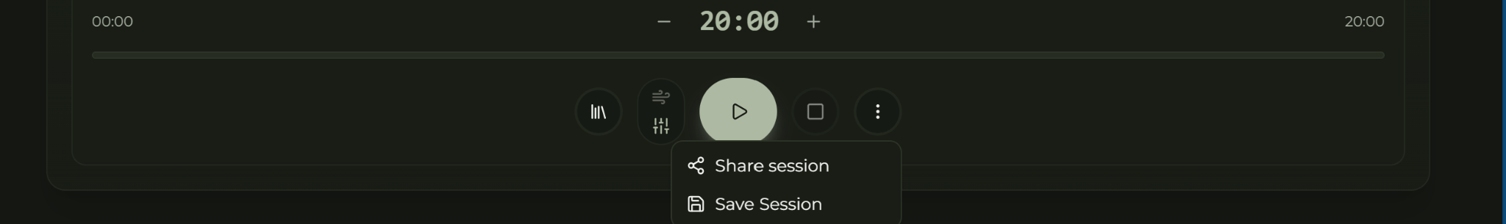

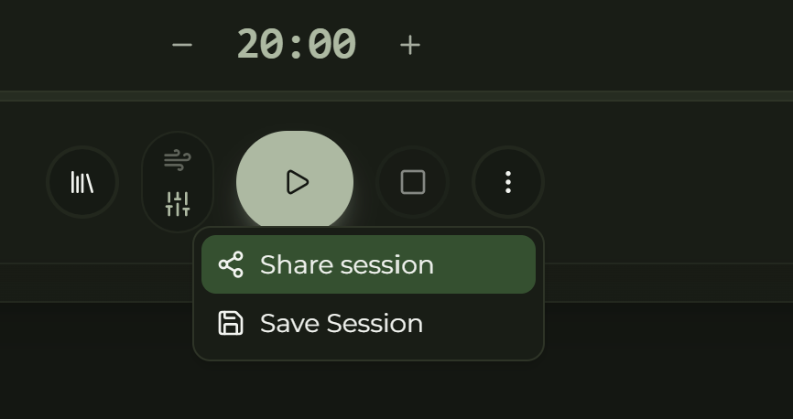

We could have something along these lines:

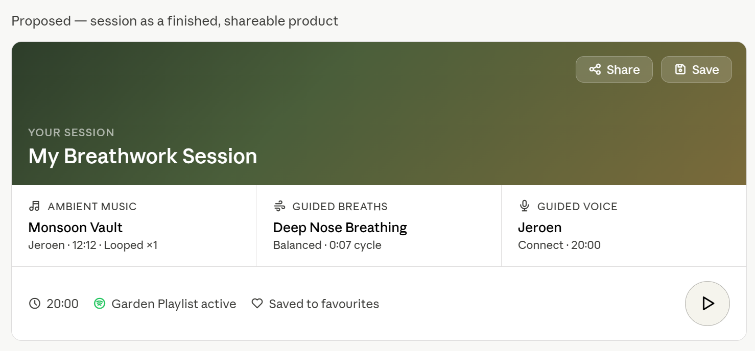

So in summary we have also decided to re-map the whole stack with all functions working the same way as the ambient music one, so that we have stronger visuals and clearer function - again this is a strong suggestion for desktop mode and UX

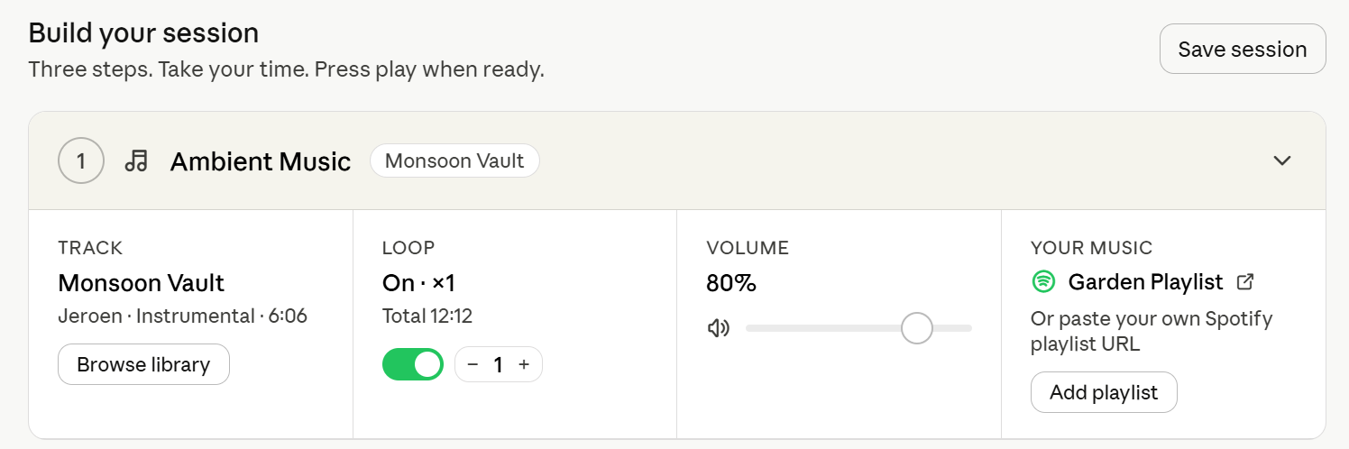
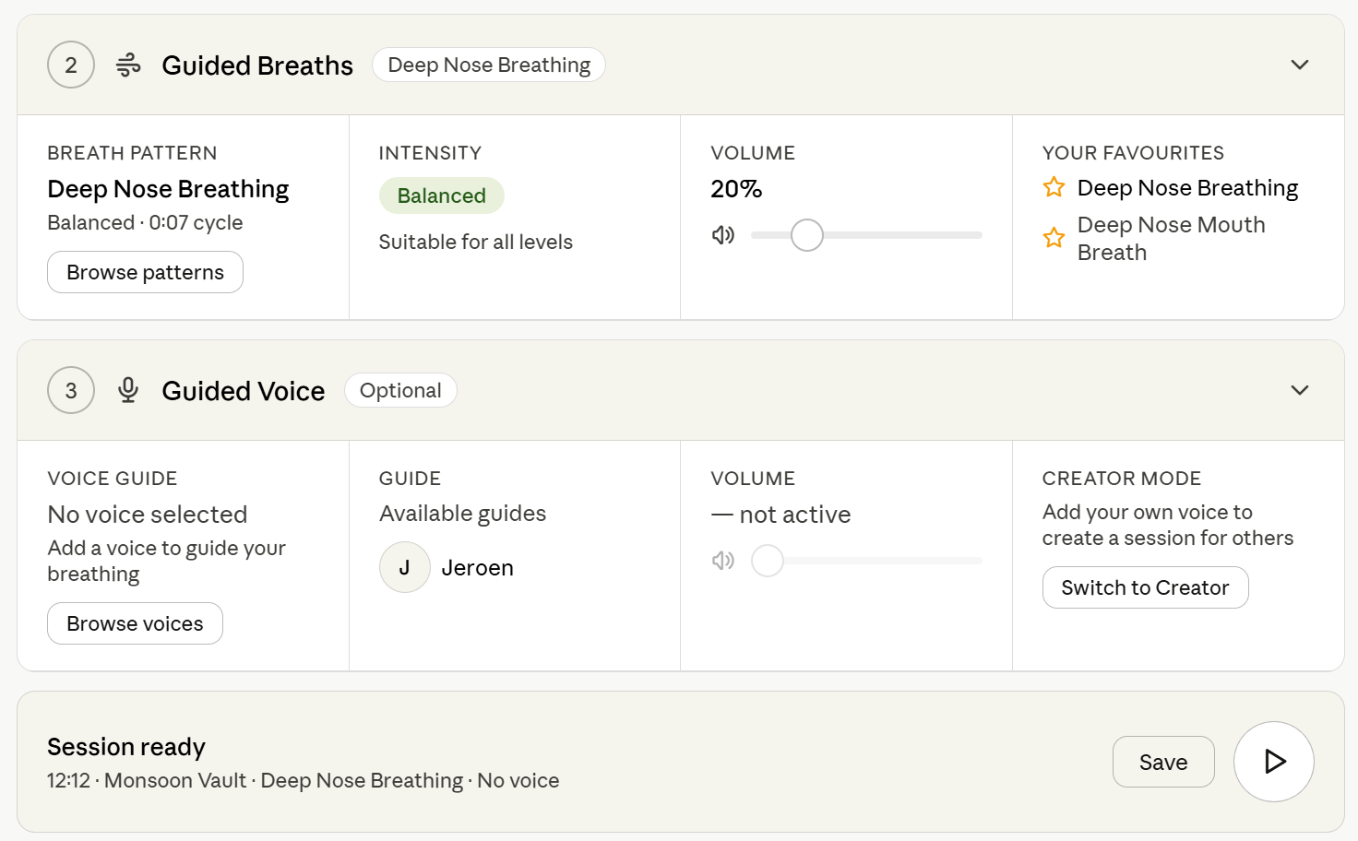

Scrap rough version below:

